**CN LAB # 01**

**Mohammad Basil Ali Khan**

**20K-0477**

**Task#01:**

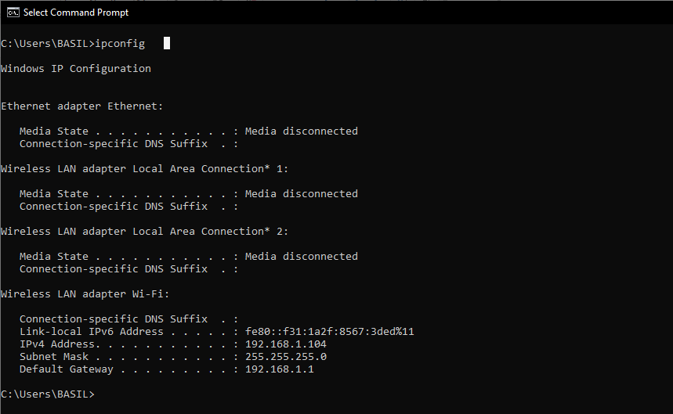

**Task#02:**

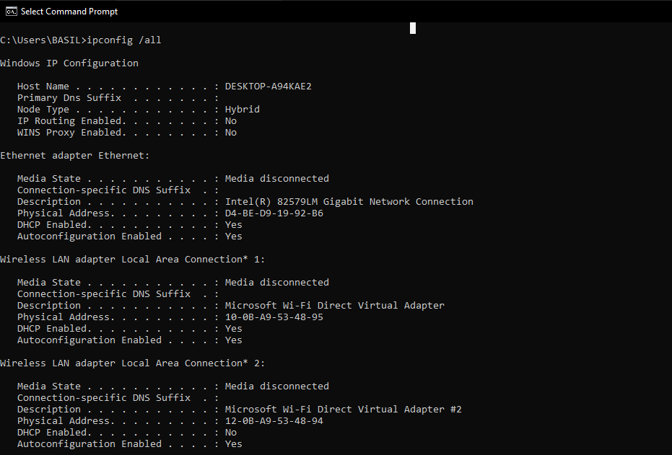

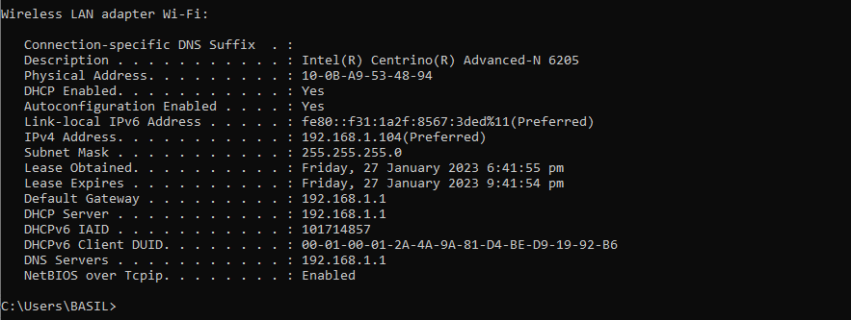

**Task#03:**

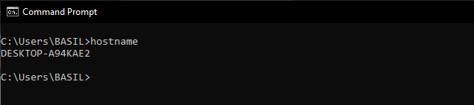

**Task#04:**

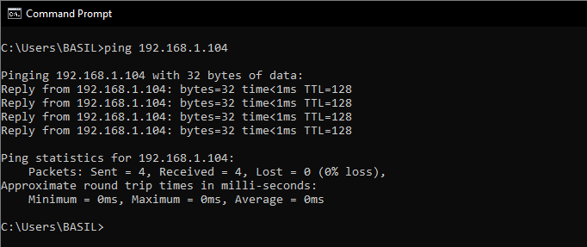

REASON: There is connection between two computers because organization already has enabled the connection. Otherwise, on personal computer there is no connectivity because Windows Firewall doesn’t allow connection.

**Task#05:**

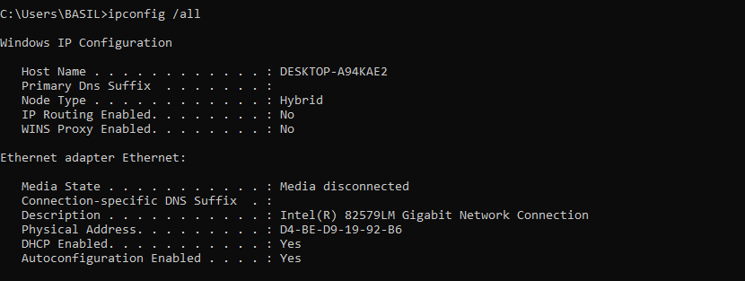

**Task#06:**

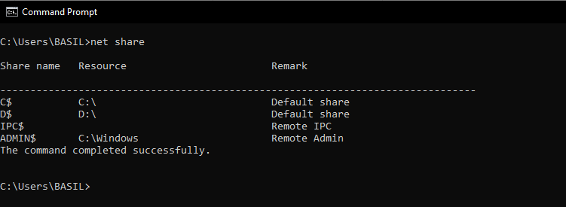

**Task#07:**

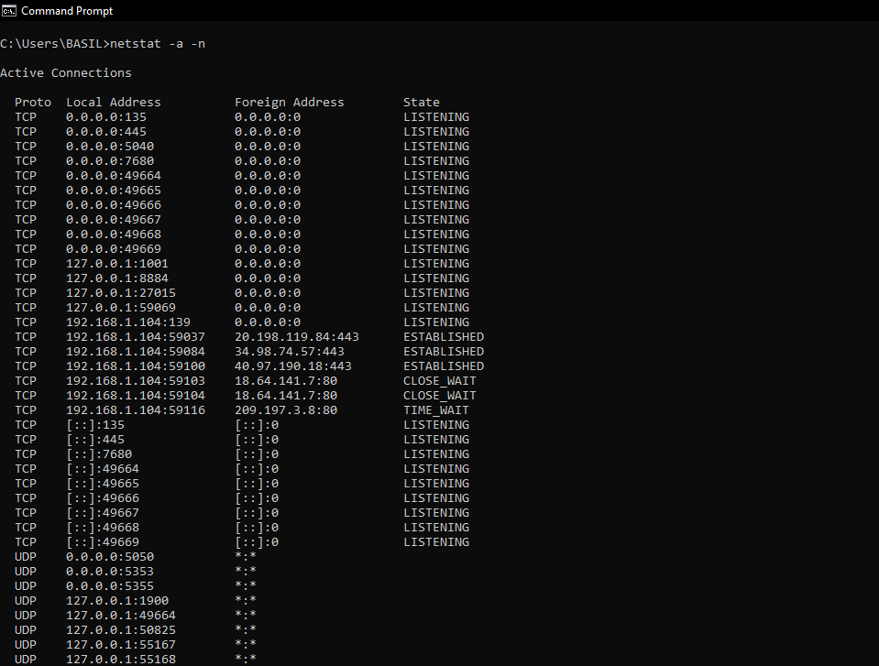

**Task#08:**

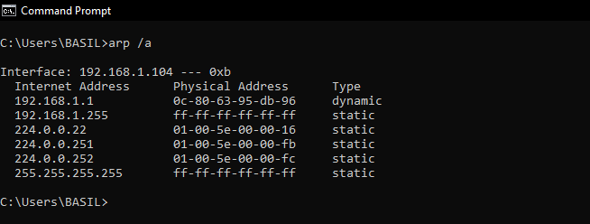

**Task#09:**

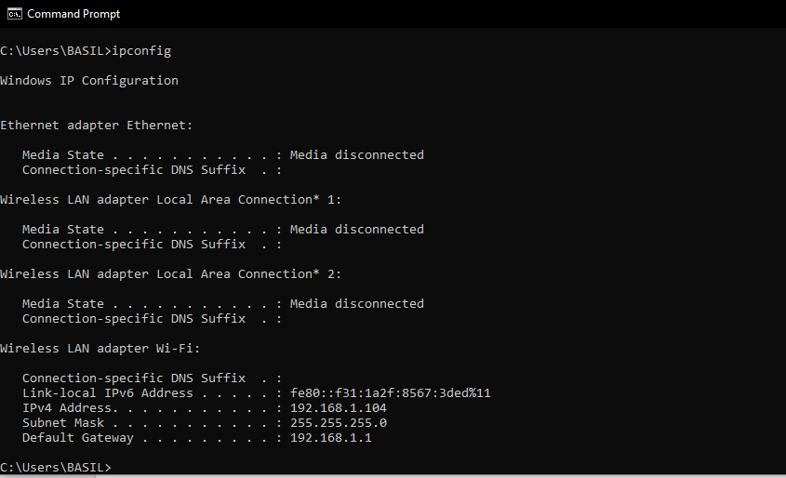

**Task#10:**

Number of hops: 14

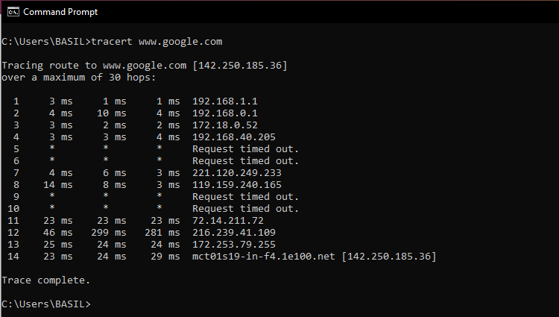

**Task#11:**

Reason: Incorrect server or machine name

**Task#12:**

Reason: Straight through cable. The Ethernet cable is attached to the router and PC and both end is different.

**Task#13:**

Yes, we can connect router to PC using straight cable because it is usually use to connect different type of devices or if switches support MDI/MDI-X feature so no need to use crossover cable which would be automatically enables when needed.

**Task#14:**

In my house all devices are connected to the router so in star topology as every device is connected wirelessly.

**Task#15:**

Number of hops: 17

